Week 12: Creation of virtual machine for Ubuntu OS and Deploying the web application
- Creation of virtual machine
- Deploying the web application
- Accessing it publicly
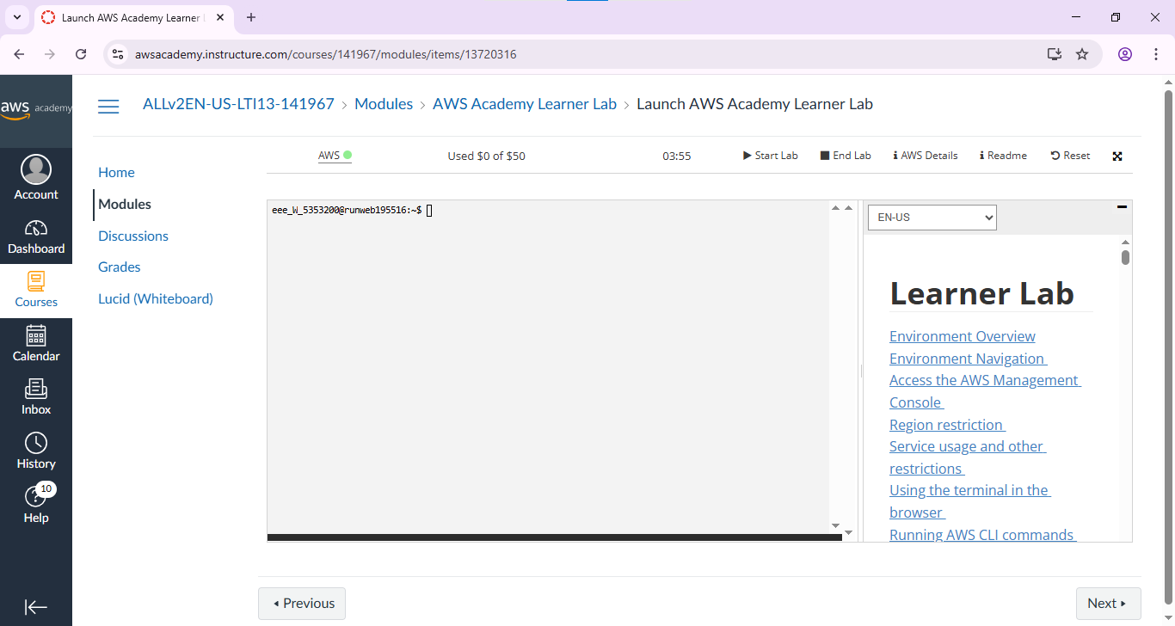

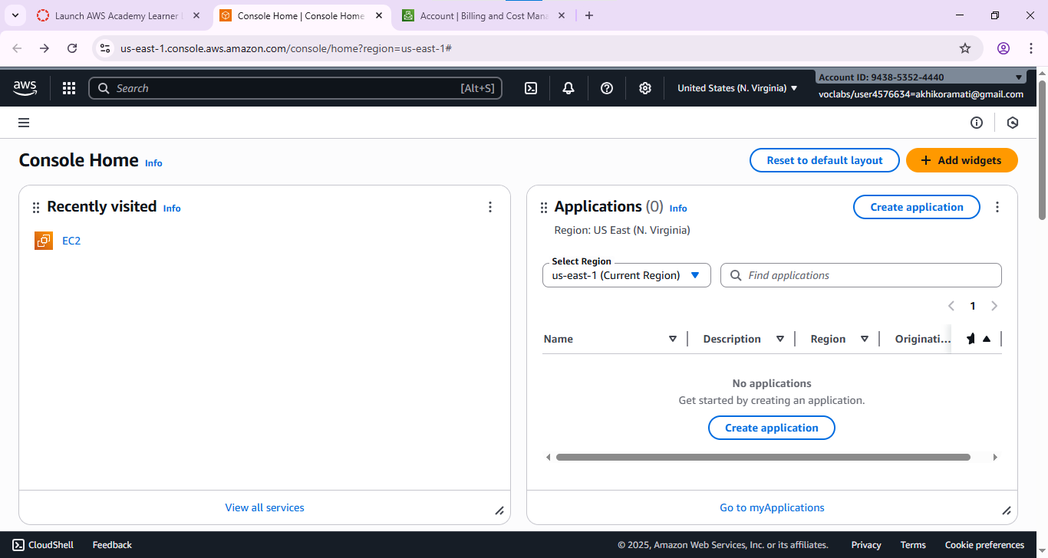

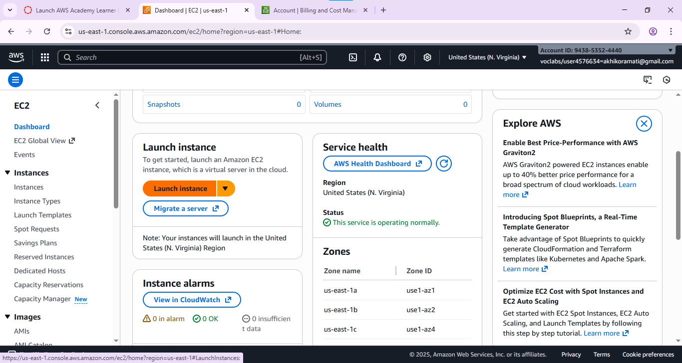
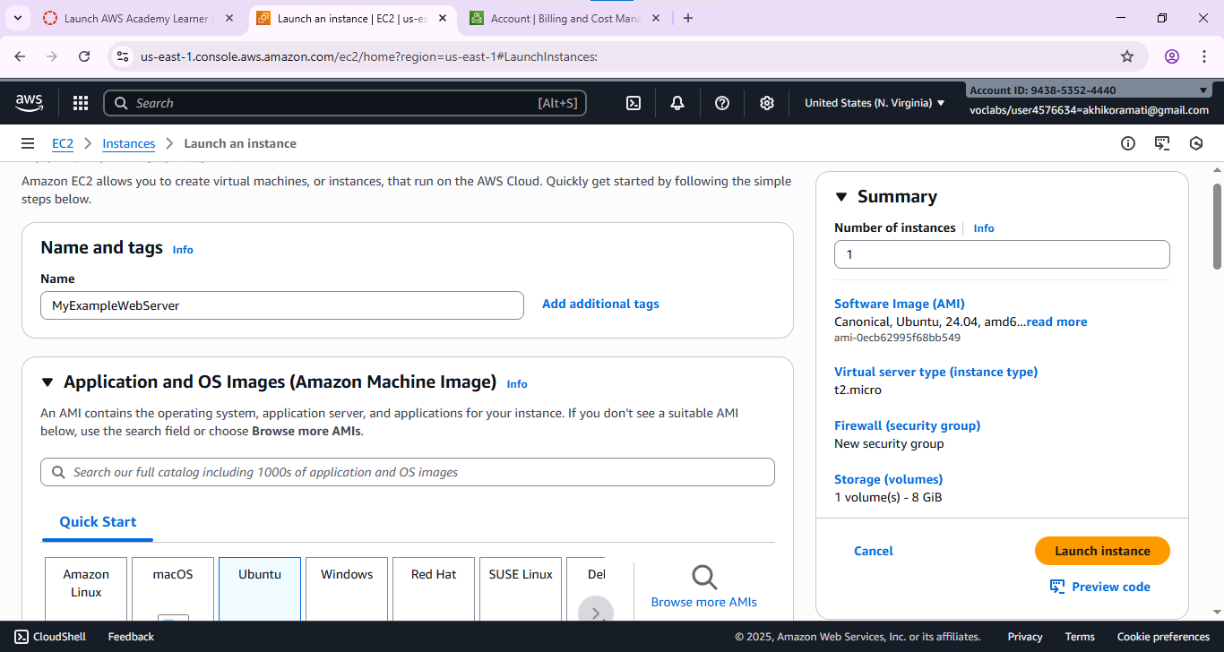
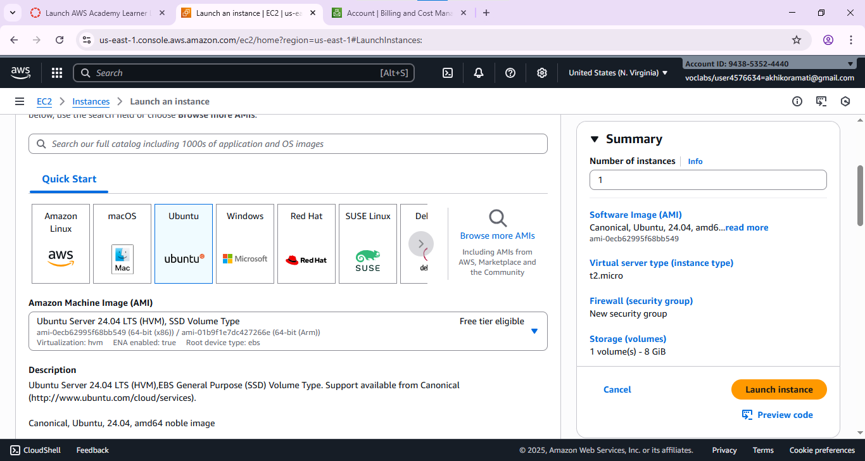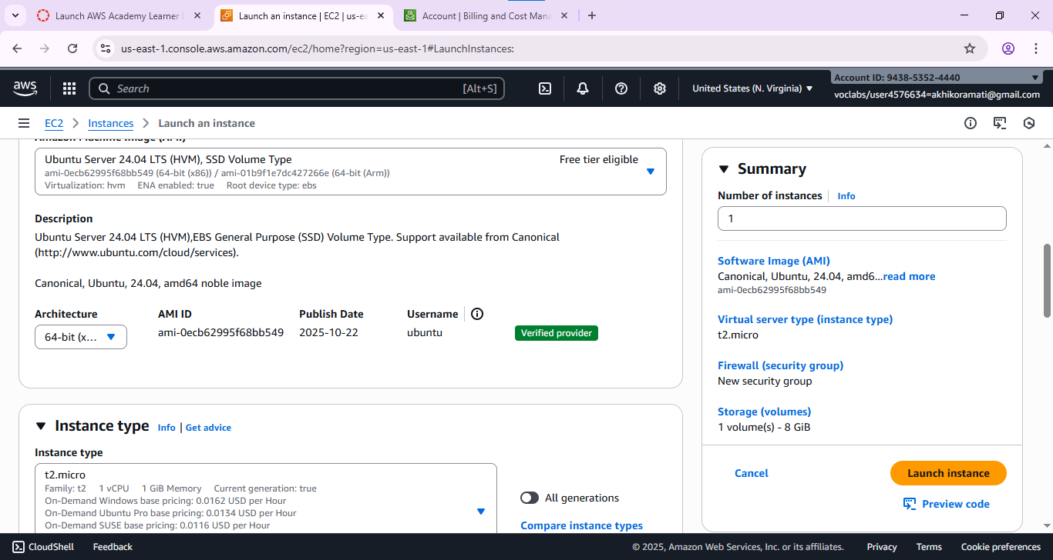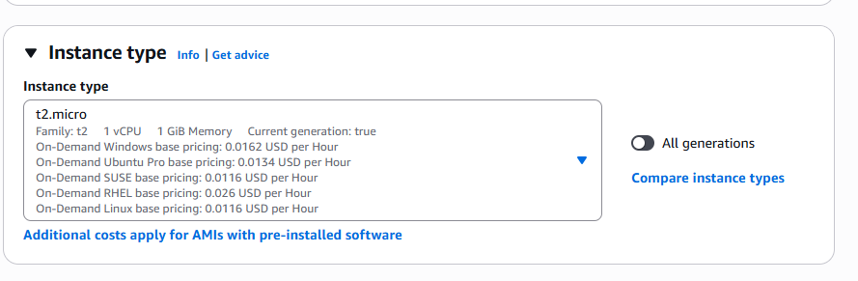
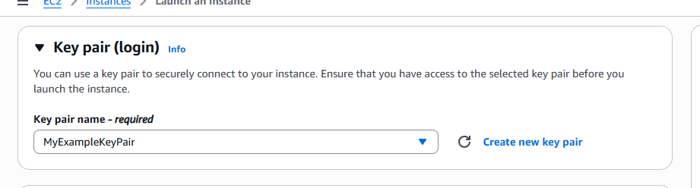

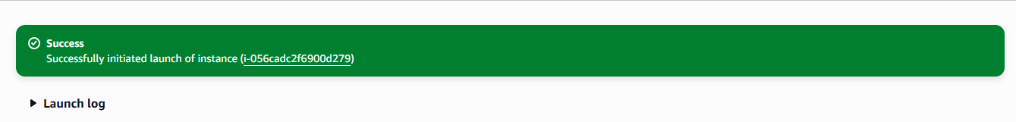
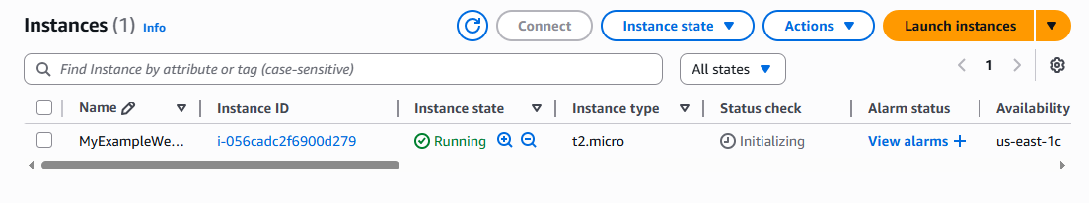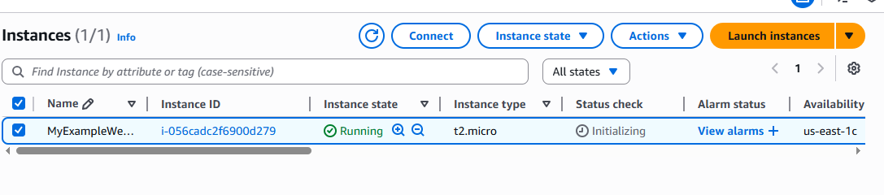
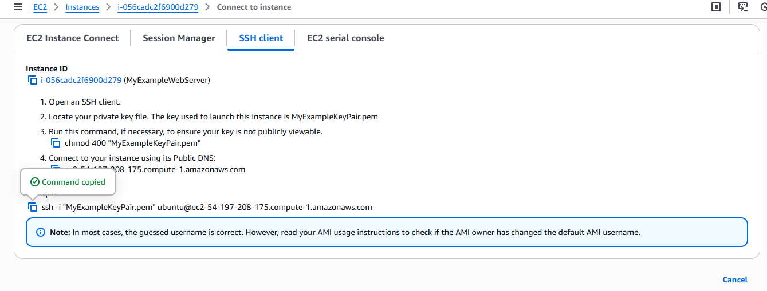
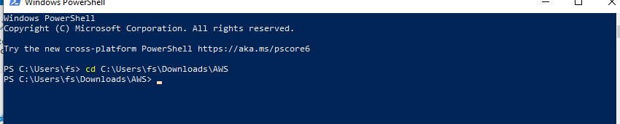
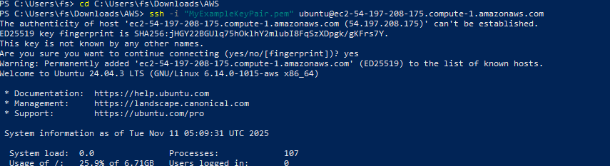
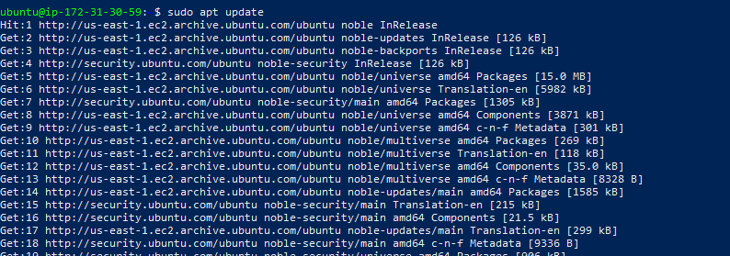
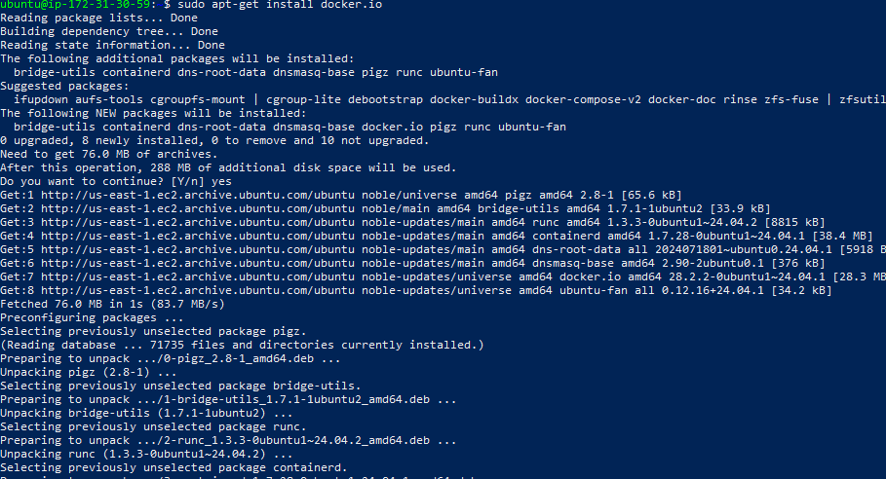
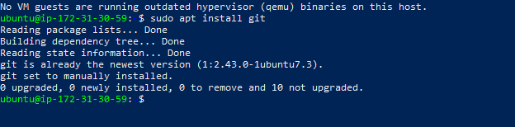
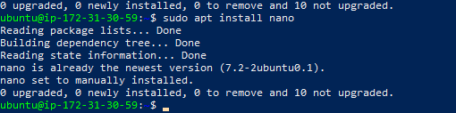
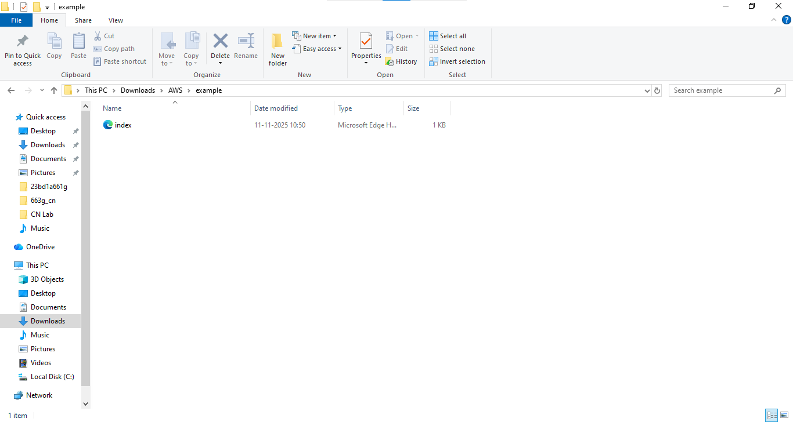

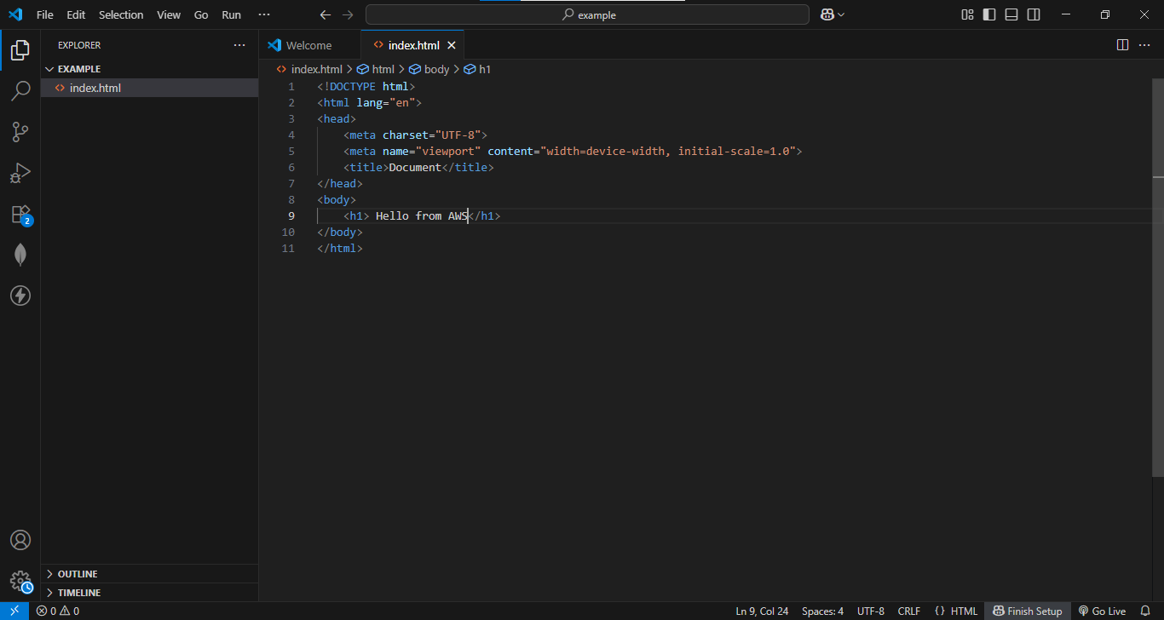

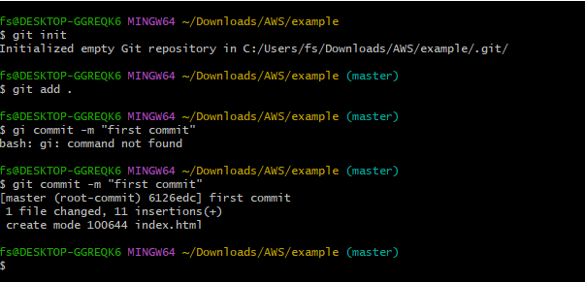
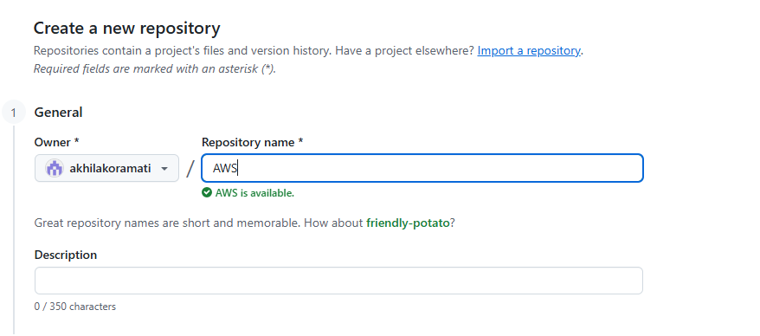
- Clone the application from github, Write the Dockerfile

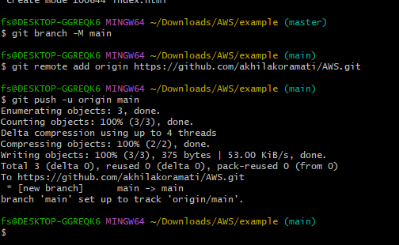
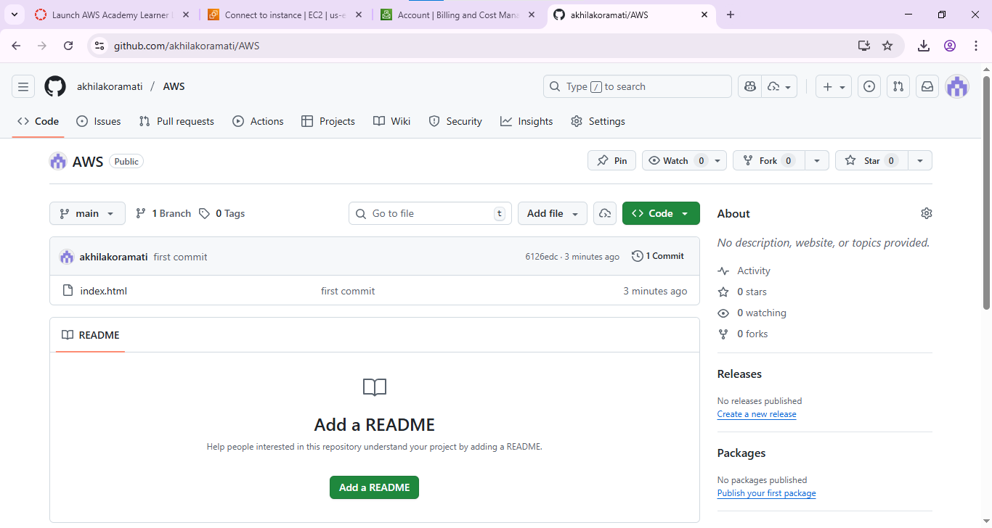
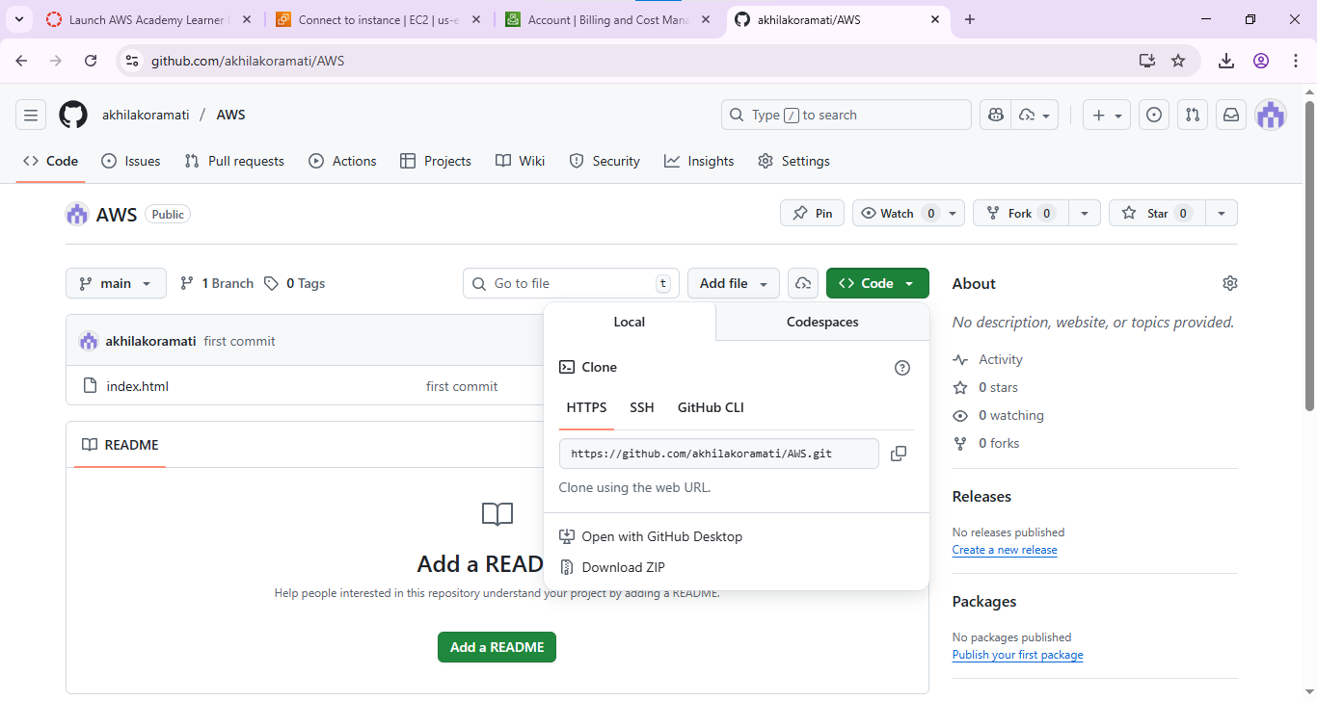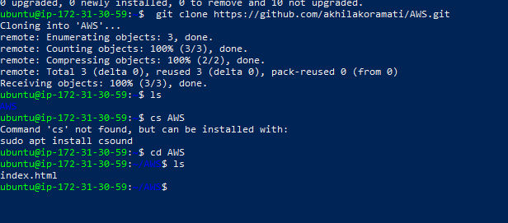
- Create the image

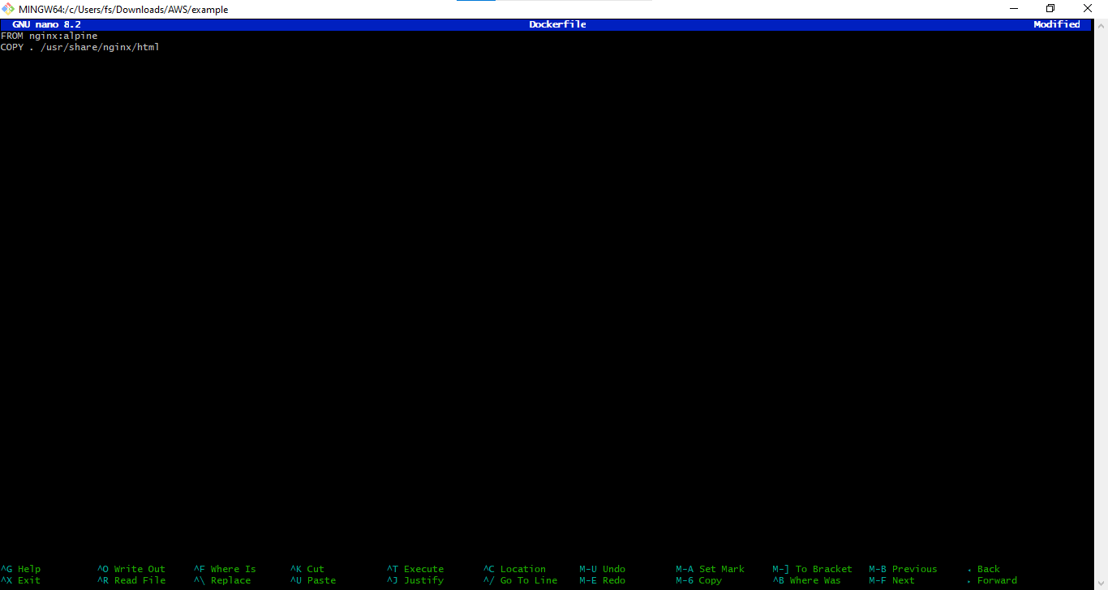
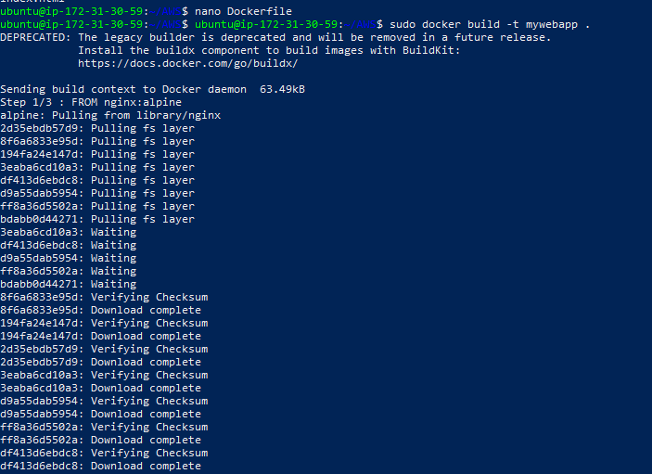
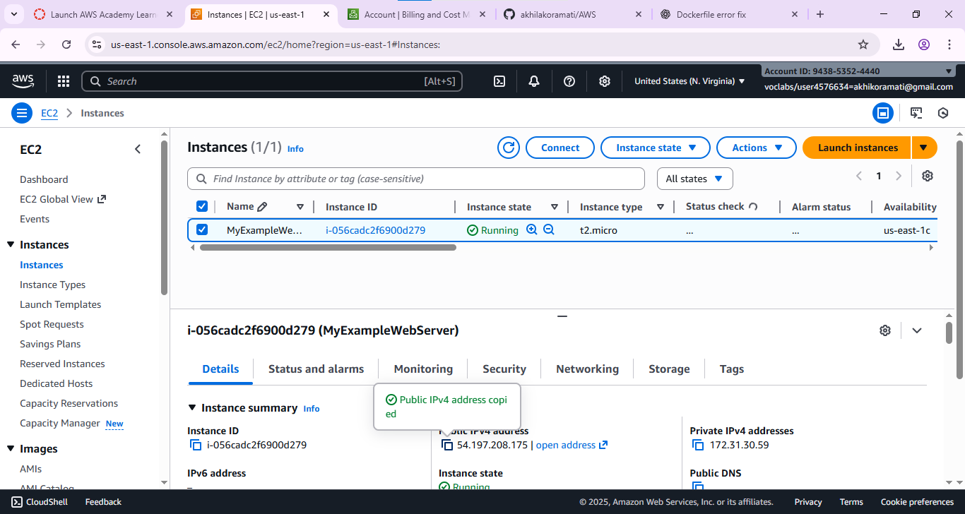

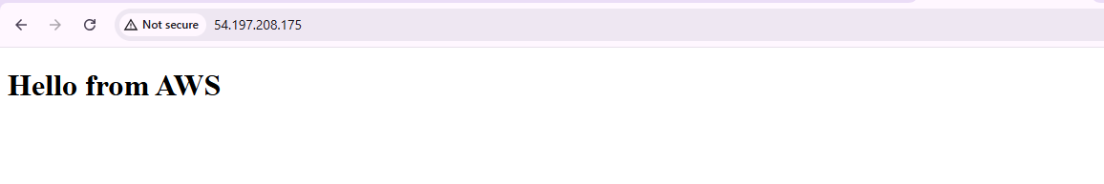
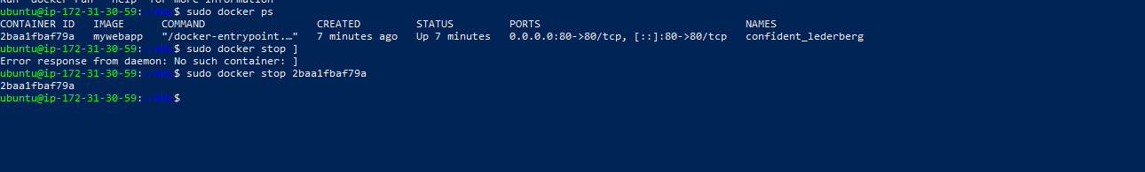
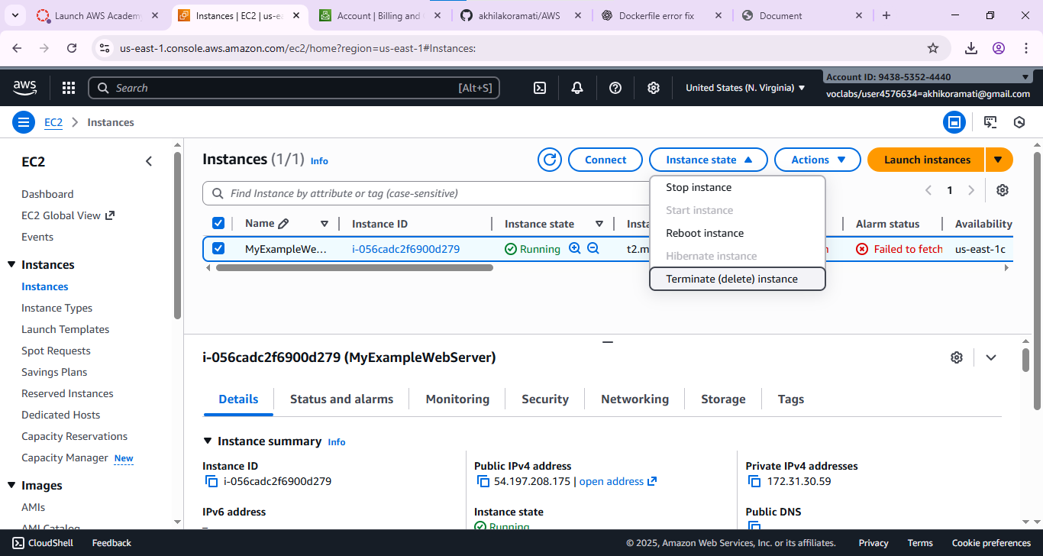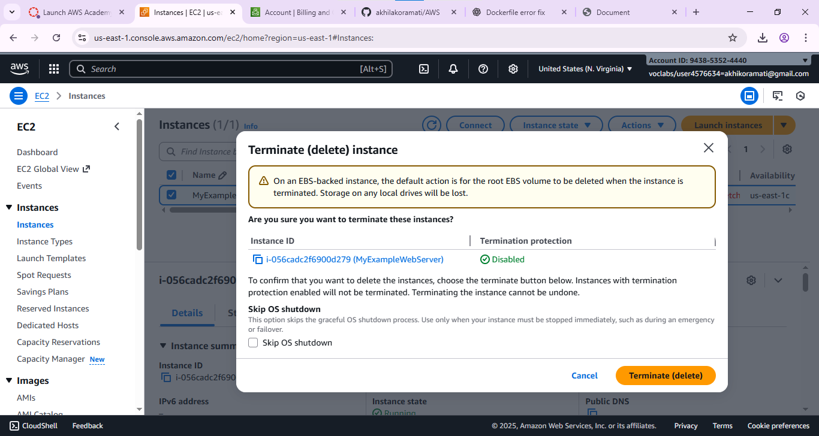
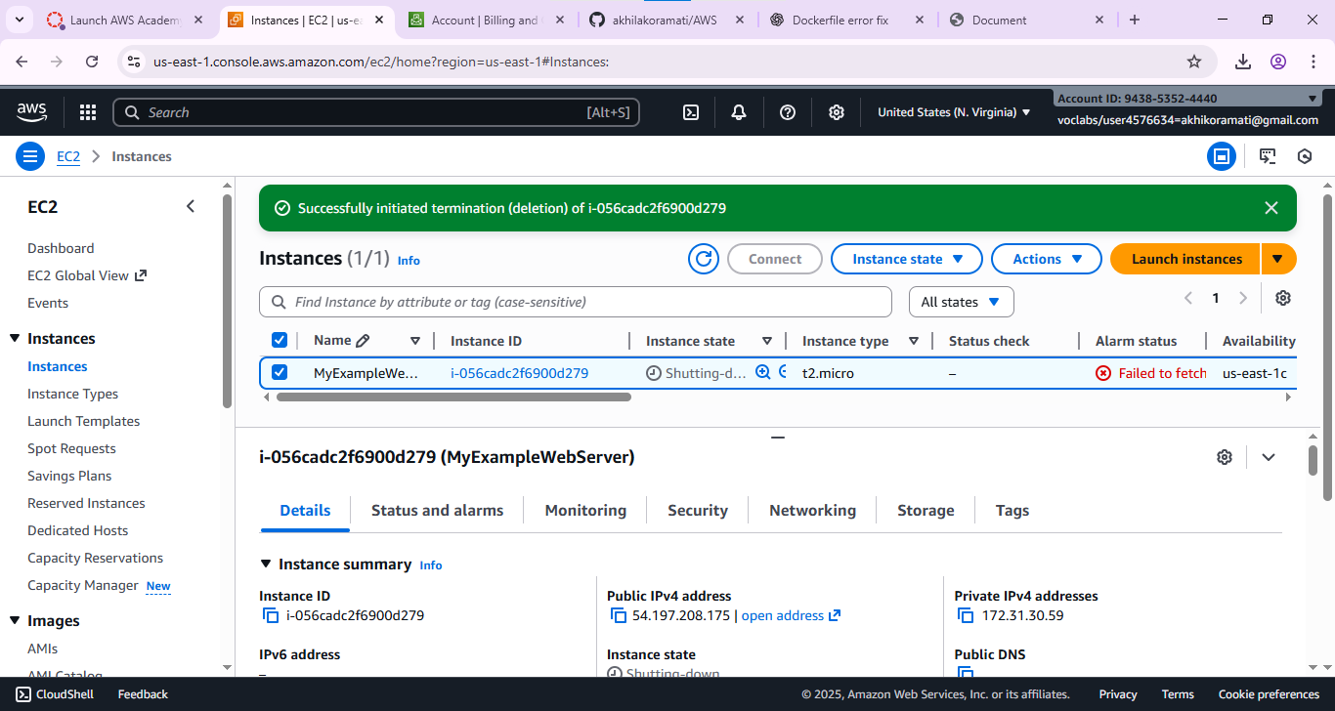
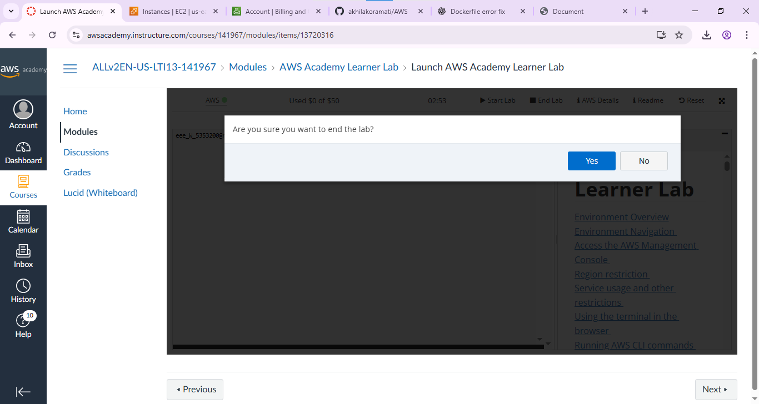
2. Maven web project Deployment in aws
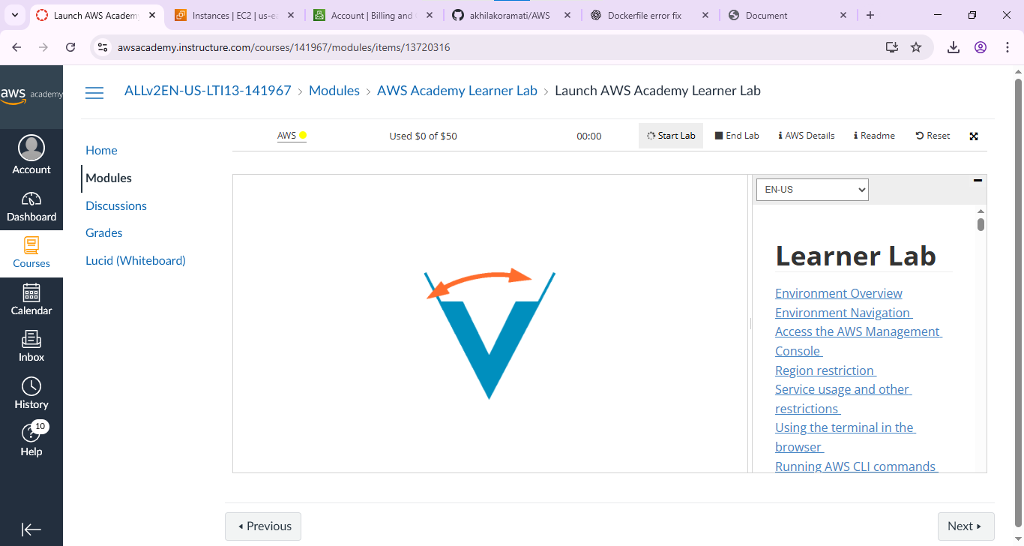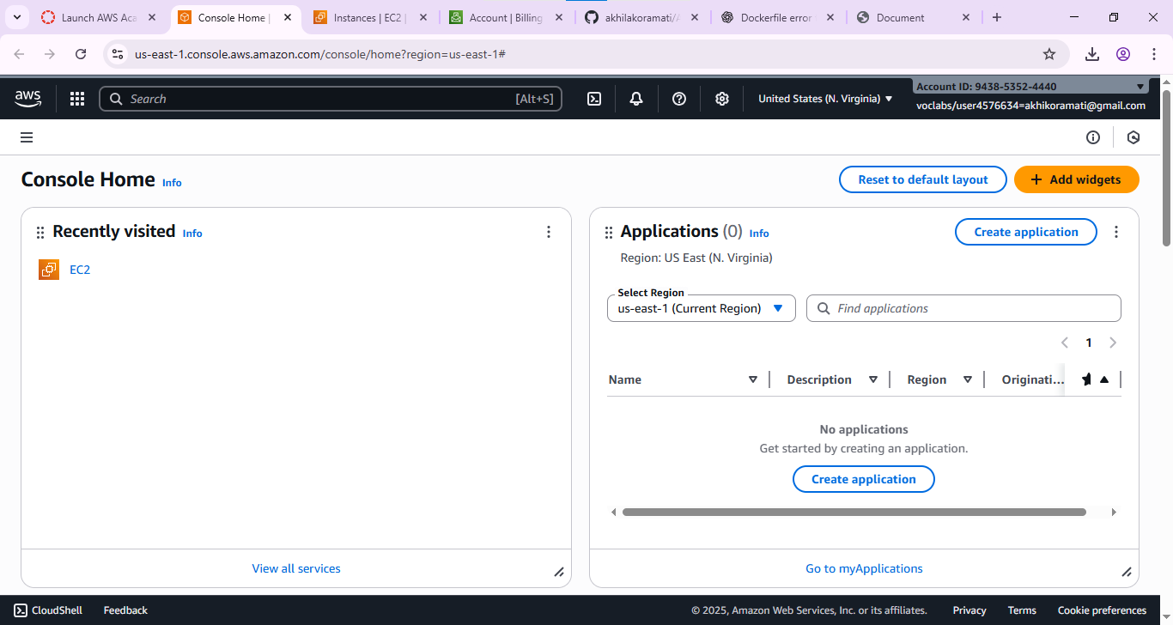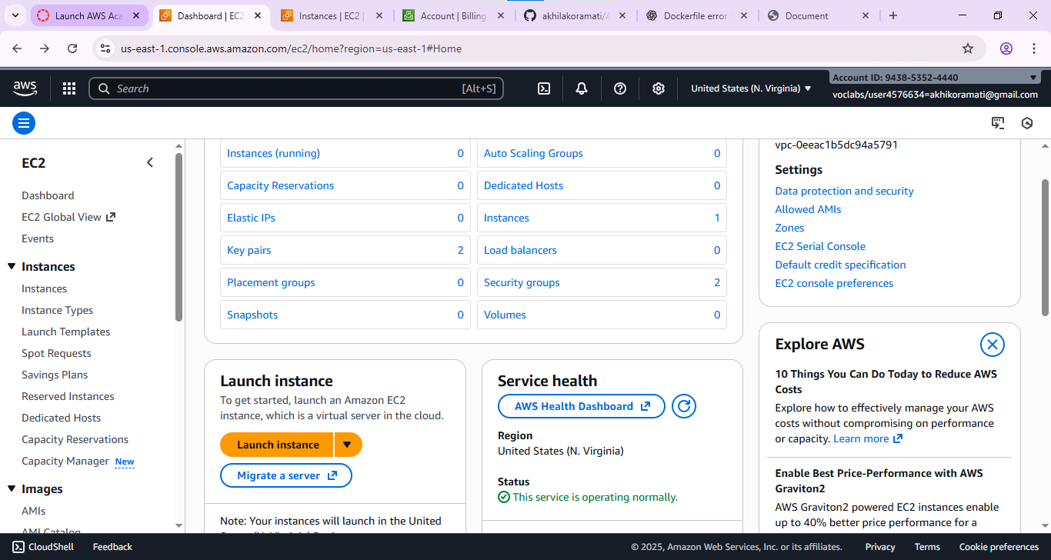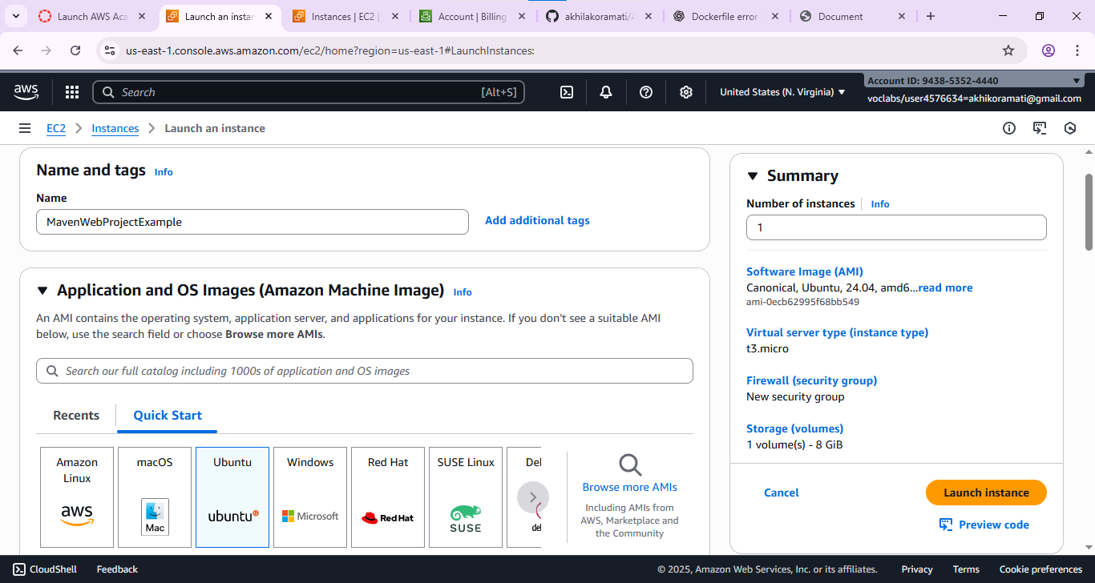
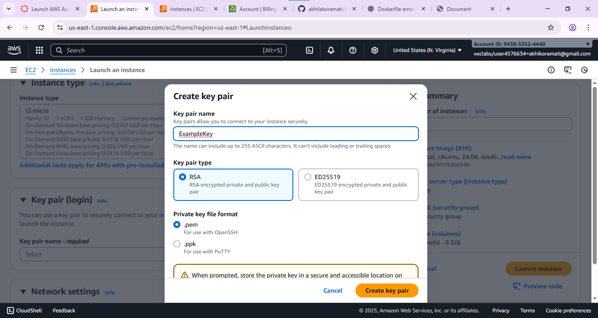
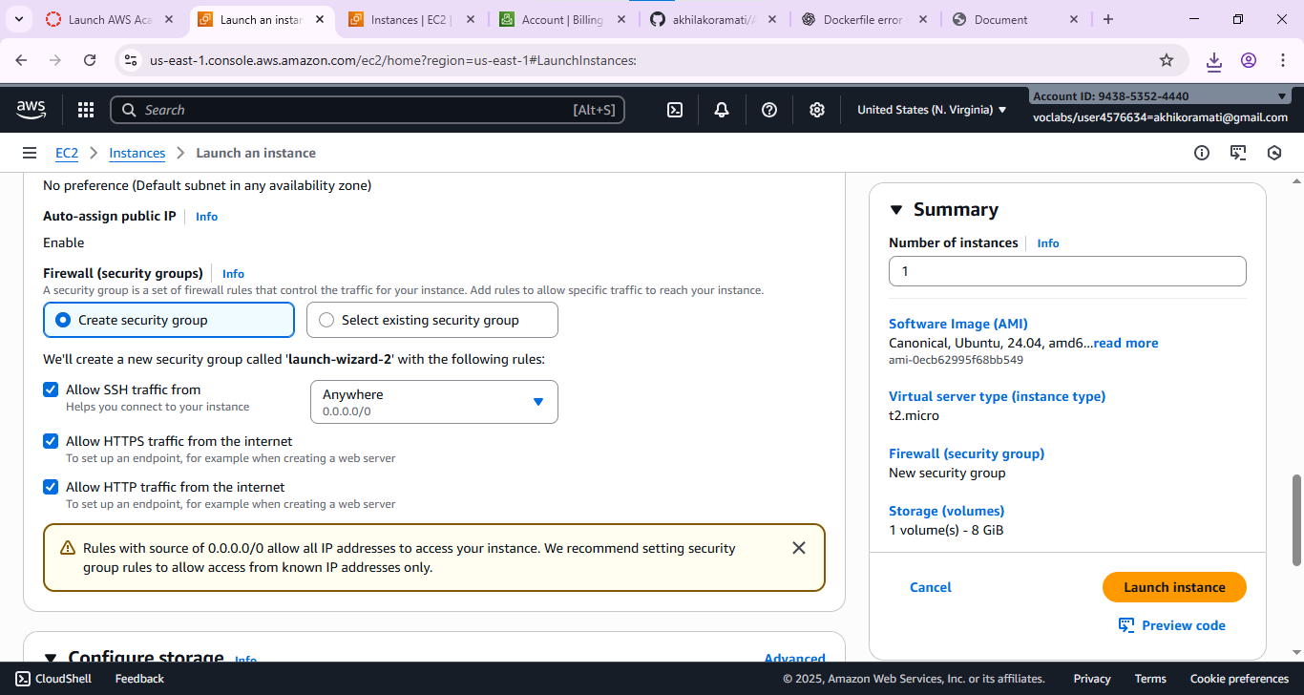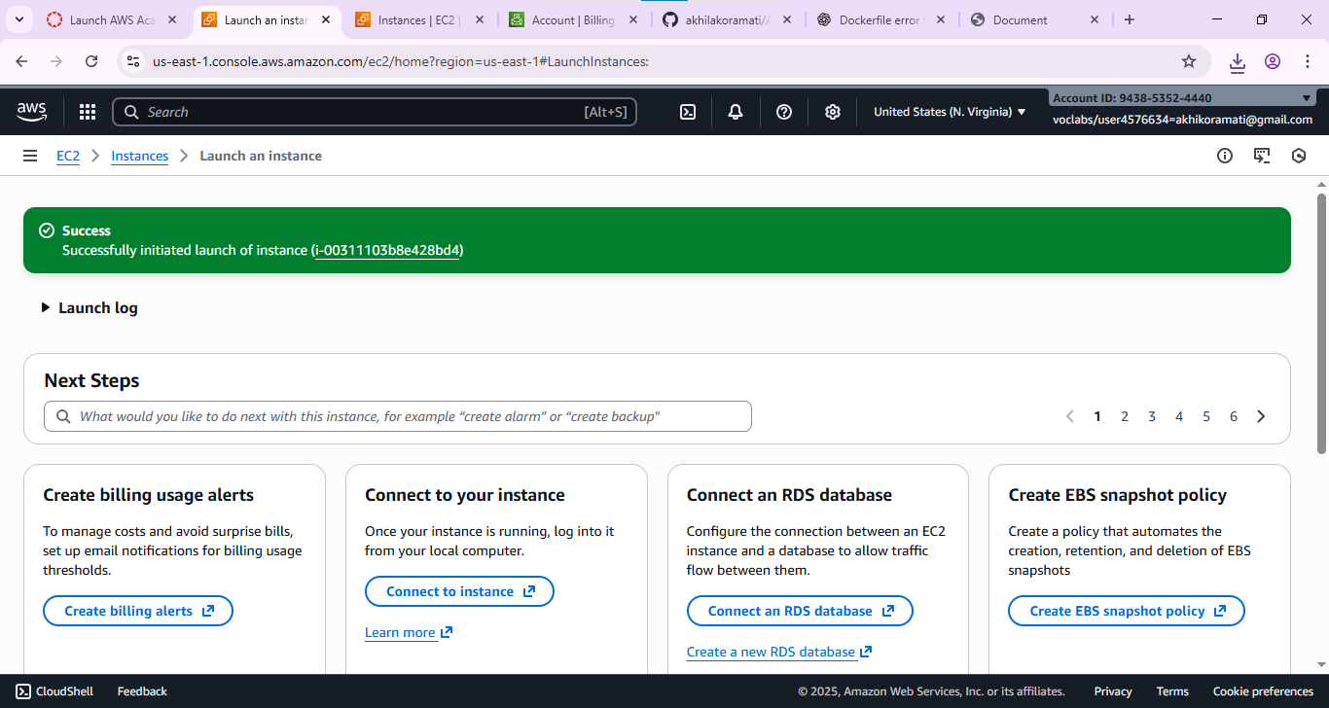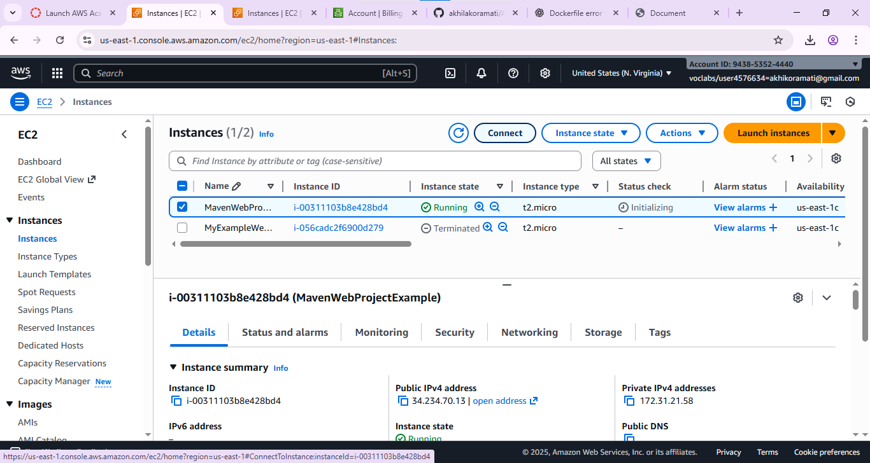

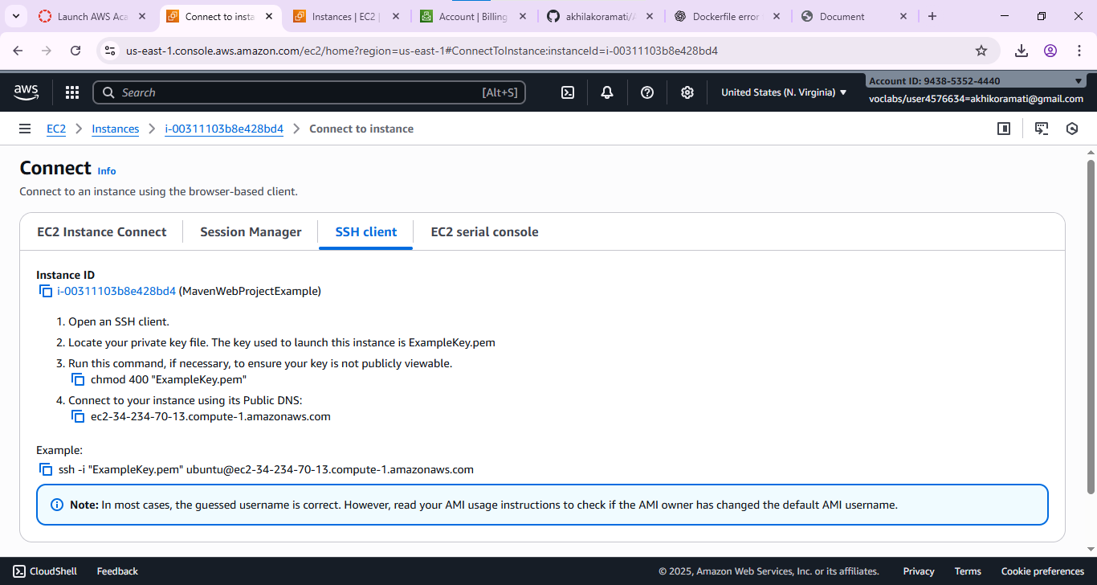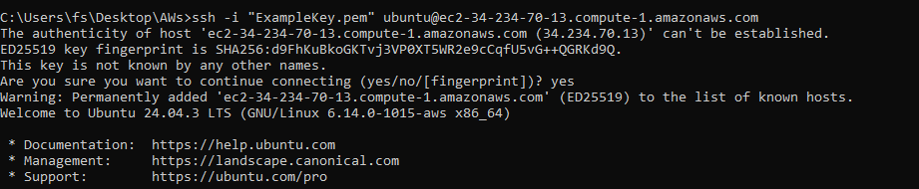
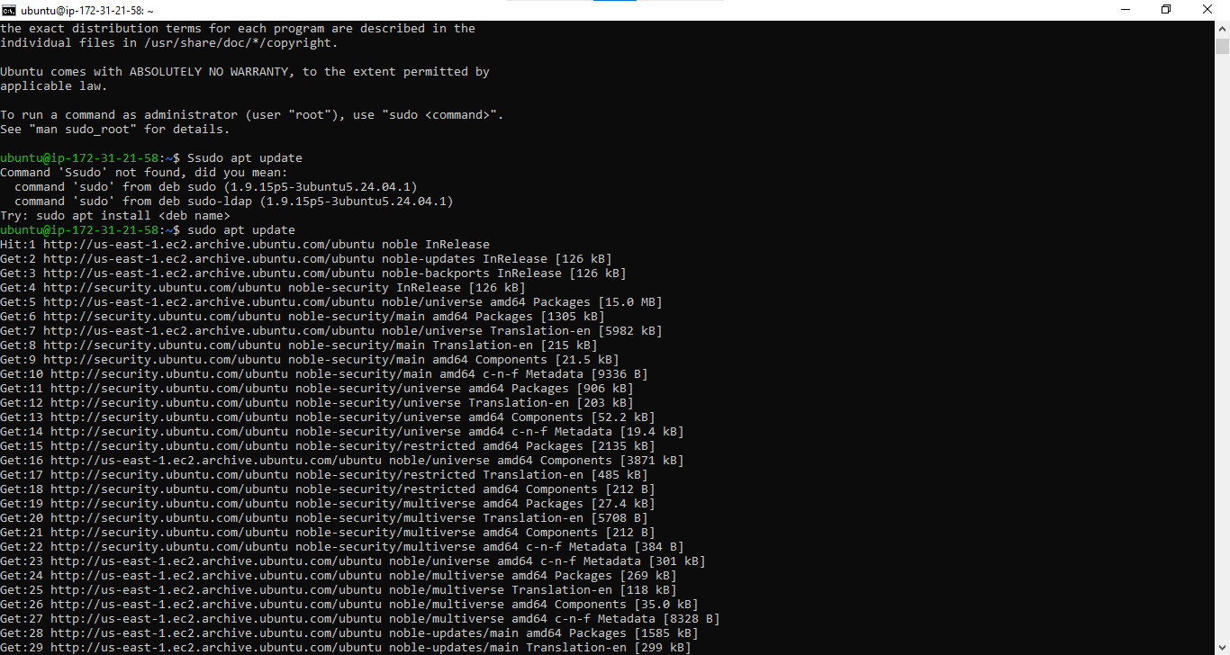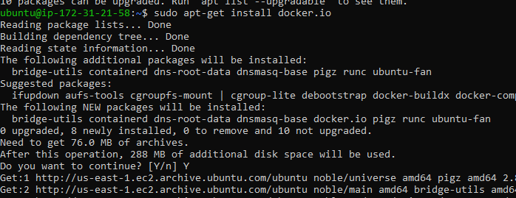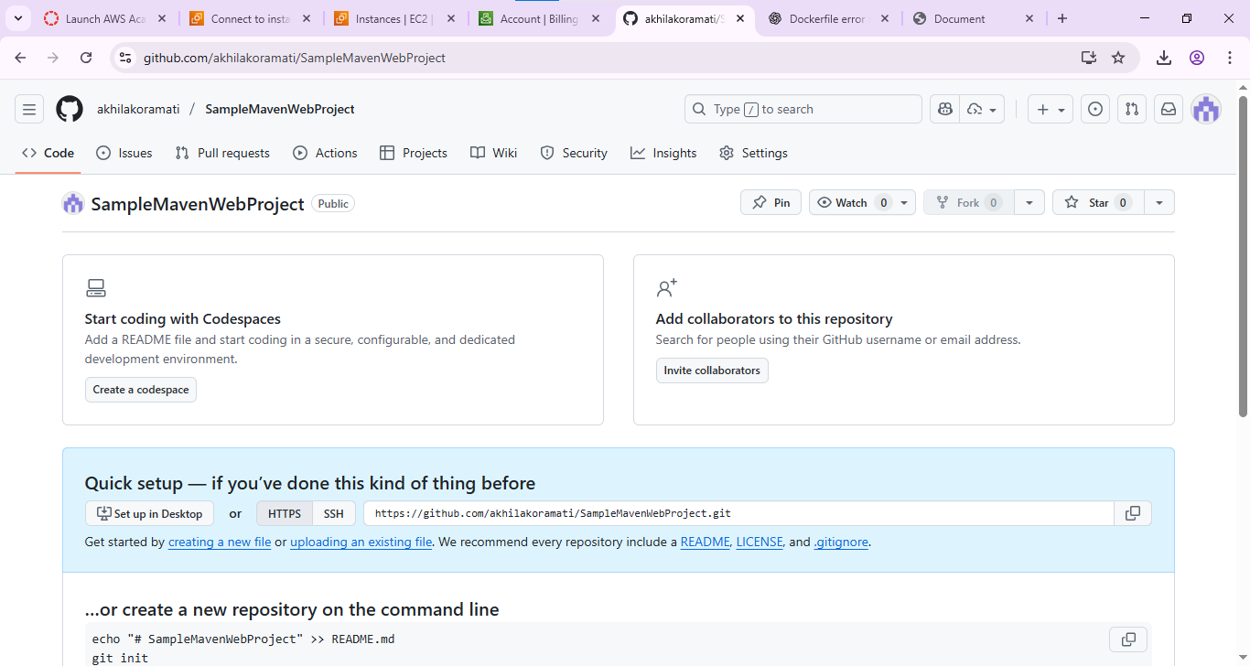

Schenerio based questions
1. You have a simple index.html file on your laptop and you launched an EC2 instance with Amazon Linux 2. The instance is running but when you open the public IP in browser, the page doesn’t load.What steps will you take to host the index.html?

ANS: Install Apache (sudo yum install httpd -y), start it, copy index.html to /var/www/html/, and open port 80 in the security group.

2. You deployed your index.html to /var/www/html/ directory on EC2, but the web page still isn’t loading.What are two possible issues you would check?
ANS: index.html in /var/www/html but not loading:
Check if Apache is running and ensure port 80 is open in the EC2 security group.

3. You installed Apache HTTP server on EC2 to host index.html, but the service stops after instance reboot. What command should you run to ensure it auto-starts on boot?
ANS:
Apache stops after reboot:
Run sudo systemctl enable httpd to make it start automatically on boot.

- You are deploying a Maven web application onto an EC2 instance.Maven is not installed on the instance. What commands or steps will you follow to install Maven on Amazon Linux/Ubuntu EC2?
ANS: Run sudo yum install maven -y (Amazon Linux) or sudo apt install maven -y (Ubuntu).

5. You built a Maven project on EC2, and a .war file generated inside target/.
You want to deploy it using Tomcat. Where will you place the .war file and why?
ANS: Place the .war file in Tomcat’s webapps directory so it auto-deploys.

6. Your Maven web app is deployed to Tomcat on EC2, but accessing it via browser gives 404 error. What configuration or path issues will you check?
ANS: Check the WAR file name and context path, and verify Tomcat logs for deployment errors.

7. You can access your web application locally on the EC2 instance using curl localhost:8080 but not from your browser. What AWS setting is likely missing or misconfigured?
ANS: Add a security group rule to allow inbound traffic on port 8080.

8. You have deployed your web app on EC2 successfully, but after shutting down your local Wi-Fi and reconnecting, the public IP changed and the app is not opening. What AWS feature helps avoid this issue?
ANS :Allocate and associate an Elastic IP to keep a static public IP.

9. You want to automate deployment of your index.html whenever you restart the EC2 instance. Which EC2 feature can be used to run commands automatically during instance setup?
ANS: Use EC2 User Data to run setup commands automatically during boot.

10. Your Maven application needs external dependencies during build but EC2 has no internet.
What AWS service or change can allow the EC2 instance to download dependencies securely?
ANS: Use a NAT Gateway or CodeArtifact to allow secure outbound access for dependency downloads.

